

**Learning Guide:**

**American Flag**



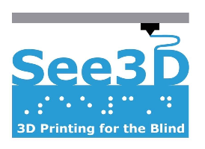

# **Overview:**



The American flag is a rectangular shape composed of 50 white stars (which represent the 50 states), and horizontal white and red stripes (which represent the original 13 colonies in the United States). The 3D printed model replicates the American flag and captures each specific detail that makes up the flag. An actual American flag is 3 feet by 5 feet (91 cm by 152 cm) on average, which is almost the size of the roof of a car.

This model was designed by Mrugank for See3D

The image above depicts a 3D model of the American Flag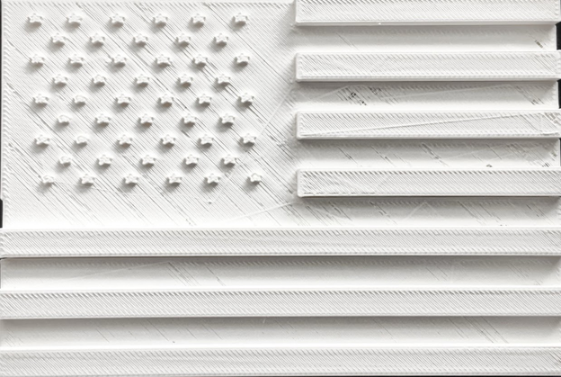

# **Walkthrough:**



1. Feel for the large group of raised stars in the top left-hand corner of the flag. Each star has 5 points and there are 9 rows of stars. In total, there are 50 stars that make up about 1/4 of the flag’s total area. The stars represent each of the 50 states in the United States of America. In the real flag, the stars are white.

2. After you have located the raised stars, feel for the surface that the stars are located on top of. Start on the top left-hand corner of the flag and move your finger to the right until you feel a raised ridge, and then stop. Once you reach the ridge, move your finger down until you are once again stopped by a raised ridge. Then, keep moving your finger to the left until the left edge of the model. Finally, bring your finger up to the top left of the model. By doing so, with your finger, you have outlined the blue rectangle that is in the top left area of the flag. The stars rest upon this blue area.

3. To the right of and below the rectangle you just outlined with your fingers, there are horizontal stripes that make up the remainder of the flag. Start in the top right corner of the model and feel for a raised rectangle. The rectangle that is raised is skinny and represents a horizontal stripe on the flag. Move your finger down the model and you will feel more of these raised stripes. After you have felt the first 4 raised stripes, you will notice that the stripes double their length and span across the entire flag. In the real flag, the raised stripes are a red color.

4. In between each of the raised stripes you just felt are the horizontal white stripes in the flag. The red and white stripes alternate, as do the raised and lowered stripes on the model. Like the raised stripes, after you feel 3 of the lowered stripes, the lowered stripes double their length and span across the entire flag. In total, there are 13 stripes (6 white and 7 red) and they represent the 13 colonies originally in America.

# **Citations:**



“Flag Dimensions.” *US History*, Independence Hall Association, 2020, www.ushistory.org/betsy/flagetiq3.html.

“History of the American Flag.” *PBS*, Public Broadcasting Service, 2020, [www.pbs.org/a-capitol-fourth/history/old-glory/](http://www.pbs.org/a-capitol-fourth/history/old-glory/).